Mind the Doors”
This trip has been crazy fun, filled with tons of little outings and has flown by amazingly fast… so fast, it’s my last night in London! Potentially ever! Lol, I will definitely never be able to afford a trip like this again… I need to go back into medicine
Anyway, we’ve been able to do so much stuff here I can hardly keep track! I’ll try to do it by day… if I can remember them! I am so thrown off time-wise!
Thursday, June 9
Our first full day in London, Grandpa Teg and I set out on a run to check out our nearby surroundings. We ran alongside the Thames River down to Big Ben and the Victoria Tower, crossed the bridge and ran up the other side past 3 bridges, the London Eye and the Aquarium. It was neat to spend some time with him and wonderful to breathe in some of the crisp London morning air. It only briefly rained on us in toward the end.
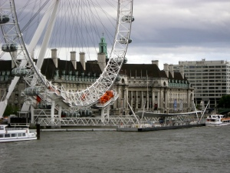
The Aquarium & London Eye
For a slow day after the flight, we drove over to Harrod’s Department Store in Kensington. Chels and I thought we’d pick up a “less expensive” scarf for souvenirs but were shocked to find that they cost about 500 pounds, or about $1000. A deck of cards cost about $80. Needless to say, Harrod’s was a bit out of our budget. We did manage to find some great sales on a few earrings.
We then went back to the hotel for a Tea Party with the Barrister’s (English for Lawyers) wives where we had some excellent biscuits and coffee. This was followed by a nice dinner at Oroso’s underground restaurant. Joan, a friend of our Grandpa’s, met us and found out we weren’t planning clubbing and promptly called hotel bartender over to set up a clubbing night for us.
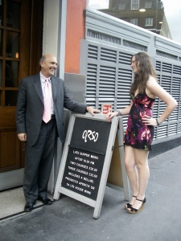
Handsome People
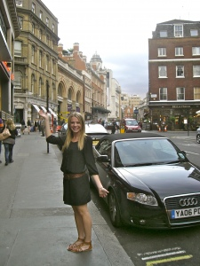
Beautiful Street
We ended up going to Mahiki, a “pretentious club where lots of Royals go” across town in Mayflower. We met a couple English gentleman there, had some Dark & Stormy’s and were supplied with free drinks for the rest of the night by a gentleman who paid $1000 pounds for a private table. It was pretty dang fun! Unsurprisingly, British clubs and attendee’s are comparatively much more respectful and less raunchy than in the U.S. Chels had a blast being legal, and we got home around 4 a.m. and ordered a baguette… lol.
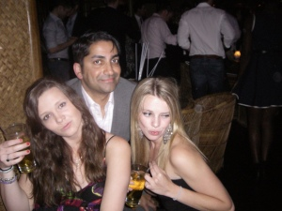
Free Drinks!
Friday, June 10
Needing something a little mellower after our previous night, we ended up taking a Big Bus Tour in which we drove around London in a double-decker bus sight-seeing. It was a perfect way for us to see the city! We saw St. Paul’s Cathedral, Buckingham Palace, St. Jame’s Park, London Bridge and a variety of other sites.
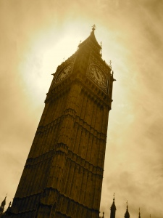
Big Ben
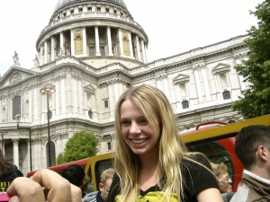
Big Bus Tour: St. Paul's Cathedral
Part way through, we stopped at the Tower of London (also known as Her Majesty’s Royal Palace and Fortress), a historic castle that was founded in 1066. The tower is known for its prisoners, executions and the fact that it is the place where the Crown Jewels are located. The castle is also known for it’s dark past including the beheading of Catherine and Anne Boleyn by King Henry VII, and the “Bloody Tower” where two young princes are said to be murdered.
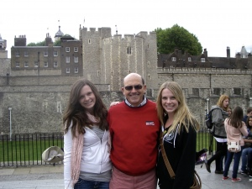
In front of the Tower of London
After the tour, we went to Old Bailey’s a British courtroom with the lawyers to witness a mock trial put on by local barristers. They still wear wigs . Starving, we went back for cocktails, hor dourves and dinner in a beautiful room in the Hotel.
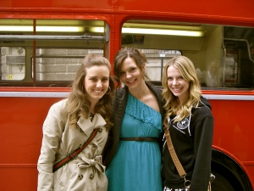
Outside the "Special Event" Bus
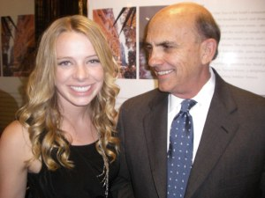
Cocktails with a Gentleman
Saturday, June 11
Our most eventful and memorable day so far, today was chalk full of surprises!
The morning was normal, Chels and I went on a river cruise and got rained on while Grandpa was in a meeting. However, when we got back, all the wives were chattering like crazy in the hotel lobby. Apparently, the Queen had just gone by in a parade on the street. Chels and I ran out to try to catch the end and ended up finding way more than we expected…
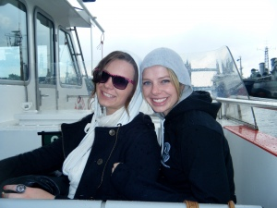
Rainy Day
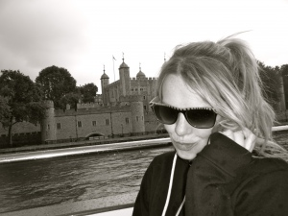
Riverside of the Tower of London
Not only did we catch a huge parade (the biggest of the year, the Troupe of Colors, the annual birthday celebration of the queen) complete with the Queen, William, Kate, Charles, the rest of the royal family and British military, but we also followed the excitement all the way to Buckingham Palace. There, we slipped behind the BBC tape and had a fantastic view of the courtyard, full of thousands of people, in front of the palace. We then witnessed the Queen and her family come out on the balcony and do the famous wave to the public. The crowd was going insane and waving flags everywhere, jets flew overhead spewing out billows of red, blue and white smoke and cannons went off in the park next to us. It was quite the celebration! I want a Royal family in our country!
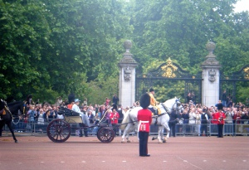
The Queen
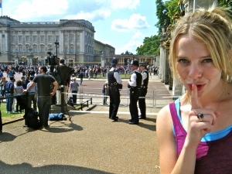
Shh, we're behind the camera lines!
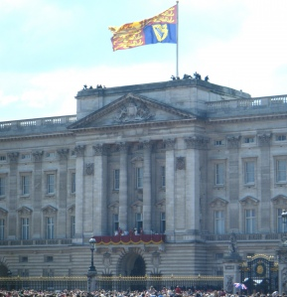
Royal Family at Buckingham Palace
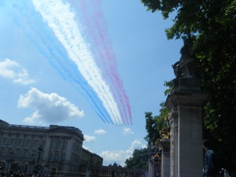
Red, White & Blue - Like us!
Later, in Trafalgar Square and on the road to Buckingham Palace, we saw about 500 nude bike riders. It was very disturbing, but kind of funny. Everyone was laughing, the group was advocating the use of bikes in the city. Pretty good way to get publicity…
There was also a “Slut Fest” in the square full of scantily clad girls protesting a politicians remark that a girl deserved to get raped if she dressed promiscuously. They were also speaking on legalizing “sex workers.” On a different note, we had a relaxing afternoon at St. James Park reading and chasing birds.
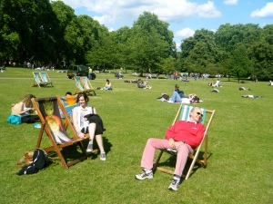
You have to pay to sit in these chairs...
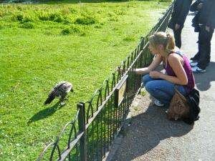
I love birds!
That night, we went to Massimo’s at the Corinthia hotel for dinner. The Corinthia is one of the world’s most elite 6 star hotels, and the restaurant matched the vibe. Chels and I really struggled to find something we could pronounce and consume there… too fancy for us. She special ordered spaghetti. I’m sure they were mortified.
Sunday, June 12
Sunday morning we attended the rockin’ Hillsong Church at London. It took place in a theater across town and was one of the hippest churches I’ve been to. We also saw the edgiest people we’d seen in London there. I got a Bible in magazine format if that gives you an idea of the feel of it.
After that, we hit up TopShop and Miss Selfridges, popular English stores, for some evening cocktail dresses. It was a super fun shopping trip fully funded by Grandpa Teg!
Dressed to imitate the elegance of the women we were attending with, we attended the finale of the lawyers conference – a cocktail party at Grey’s Inn. It’s a beautiful old English building rich with history where lawyers, or barristers, have their offices and also reside. The dining room felt like something out of Hogwarts and was in fact a place where Shakespeare ate. By the way, everywhere I go I compare things to Harry Potter, I am such a nerd.
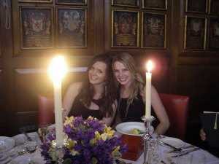
Old Bailey's Dinner
Chels and I finished the night with a PJ run to the bar for Kahlua & Creams. I spilled mine and skyped David . So good talking to him!
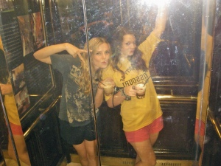
In the lift, "Mind the Doors!"
Monday, June 13
Gosh I’m sick of typing…
Today we slept in, went to the British Museum and saw Egyptian mummies, went souvenir shopping and went to a FABULOUS Italian restaurant, Luccio’s. The place was so classy and the food was absolutely succulent! It literally melted in your mouth.
Luccio, the owner, had been to Vista Verde a couple times and told Ben we should stop by. We did a surprise last-minute visit and found him, a lovely and delightful elderly Italian man, in a Steamboat Springs belt buckle with a tacky Vista Verde water bottle displayed amidst his expensive liquor collection. So funny, yet so honoring! He started us off with the cutest peach drinks and comped our meals “for Ben’s daughters.” Thanks Papa!
Epilogue
So yes, wow! That’s been our London stretch! I AM SO DANG BLESSED! And having so much fun! Oh, and ”Mind the Doors” is what Chels and I hear and repeat every time the elevator, excuse me – lift, closes Goodnight, gotta go pack for Paris!
<3 Amanda

